**LAB#14**

**Cognitive Walkthrough**

1. In LAB#08 I made a calendar app as I found out that some things needs to be changed as I apply and think thoroughly, after taking from perspective of a user mind, in three screens I found out there is need to be of some changes these changes must have done by the cognitive experts so that the user will not experience difficulty and confusion using these three interfaces as I see and think through from user perspectives that how will user think when he/she use this app and this three interfaces needs to be changed so the user will not find any difficulty and confusion regarding using the calendar app.
2. Given below are the three interfaces which needs to be changed where I found that user can be get confuse when he will use that interfaces and this confusion will then convert into frustration and in anger and result will be dissatisfactory from user side.
3. As mentioned screen no. according to lab#08

Screen#07

Screen#05

Screen#04

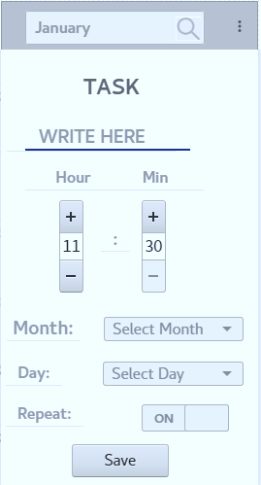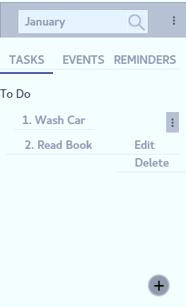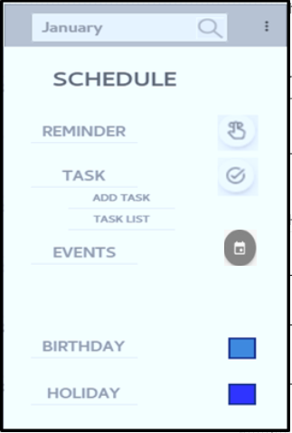

**Problem that I found in above Given Screen and their Solutions**

1. In screen#04 there should not be an extra sub menu like add task separately because user will found out too many ways to enter or achieve same task and get confused as user can achieve same task as enter in task menu to add task in to do list as shown in the screen#07.
2. In screen#05 there should not be hour, min and repeat option would be there as people do not need this, this things already present in remainders tab so the user will achieve same task inside reminder tab.
3. In screen#07 there should not be sub menu for delete and edit the task because user find it difficult because some user are not so literate they can easily understand edit, delete when we use edit, delete icon instead of another menu

**Cognitive Problems Occurs Like**

1. Perception and recognition to achieve a task or to use some functionality would get wrong impact on user if recognition of a certain task is not clarified than user get frustrated and perception impact would get be wrong because of this thing user will think that all apps are hard to use if he/she uses this types of calendar apps
2. Learning would be less and memorization will get effected, user learning semantic model would be affected and if this model not correctly stored in user mind then there is a chance of occurring error in human learning, understanding and skill acquisition.

**Analysis focuses on goals and knowledge**

1. Above Suggested design will help user to achieve his goals, he can easily understand the flow of activities and menus, sub menus or contextual menu.
2. As I see in Lab#08 I didn’t find out any other major problems unless these three that I have mentioned above.
3. The flow of using calendar app will get smooth if we apply suggested solutions for given interfaces as I have already mentioned above.

**Heuristic Evaluation before Suggested Solutions in Cognitive walkthrough**

1. User find out that system consistency is affected like, the task should be done is not get done correctly and we need to use more options which are not necessary, as we discussed user find out more non-relatable option on setting task by going inside add task tab.
2. User will find out it less predictive as it is not matched with user model because user think that each thing will go in a flow but due to the some extra unnecessary stuffed he/she didn’t memorize and learn that how task should be done and multiple interfaces to achieve same task would confused user and this will turn him to anger and result would not be satisfactory.
3. Feedback system already present and effectively working and responsive as I already shown in lab#08.

**Heuristic Evaluation after Suggested Solutions in Cognitive walkthrough**

1. User will open app and easily can see and read date and day in above menu they can easily found out basic options to achieve their task like set reminder, add events like birthday and add task in task list as they set task, reminder and events first time they will easily learn each and every thing quickly and memorize it easily as flow of all functionalities and interfaces are properly observed and enhanced.
2. Noting more we have to change because person would easily find out setting options to change day and date and set it properly also notification on and off toggle button easily help user to achieve its task.
3. Help menu will guide user how to use app and feedback system would alert user as I have already shown in lab#08.
4. User will easily predict how to achieve or how to do task.
5. User will find out consistency in achieving task.
6. Feedback system is already provided